CUSTOMER RETENTION & CHURN ANALYSIS
Task 2 — Data Science & Analytics Internship
Submitted by: Ishita Das

1. Project Overview
Customer retention is an important factor in the long-term success of a business. Losing customers can reduce recurring revenue and increase the cost of acquiring new customers. Therefore, identifying customers who are more likely to leave helps businesses develop effective retention strategies.
The objective of this project is to analyze customer churn, identify patterns associated with customer departures, and understand how factors such as contract type, customer tenure, and payment method relate to churn.
The analysis was performed using Tableau to create an interactive dashboard containing key performance indicators, visualizations, and business insights.

2. Dataset Description
The Telco Customer Churn dataset contains customer-level information about telecommunications services, account details, billing arrangements, tenure, and churn status.
The dataset contains 7,043 customer records and includes the following important fields:
- CustomerID: Unique identifier for each customer.
- Churn: Indicates whether a customer left the service.
- Tenure: Number of months the customer has stayed with the company.
- Contract: Type of contract, such as month-to-month, one year, or two year.
- PaymentMethod: Method used by the customer to pay bills.
- MonthlyCharges: Monthly amount charged to the customer.
- TotalCharges: Total charges accumulated over the customer's relationship with the company.
These attributes help identify patterns in customer retention and churn.

3. Data Preparation and Methodology
The dataset was connected to Tableau for analysis. Relevant fields were reviewed, and calculated fields were created to measure customer churn and retention.
The following key metrics were used:
Total Customers: Total number of distinct customers in the dataset.
Churned Customers: Number of customers whose churn status is marked as “Yes.”
Churn Rate:
Churn Rate = (Number of Churned Customers / Total Customers) × 100
Retention Rate:
Retention Rate = 100% − Churn Rate
Additional calculated fields and visualizations were created to compare churn across contract types and tenure groups, as well as across payment methods.
The analysis focuses on identifying patterns and relationships in the data rather than assuming that any single factor directly causes churn.

4. Key Performance Indicators
The dashboard presents the following key metrics:
Metric | Result
Total Customers | 7,043
Churned Customers | 1,869
Churn Rate | 26.54%
Retention Rate | 73.46%
The results indicate that approximately one in four customers has churned. Although most customers remain with the company, the churn rate represents an opportunity to improve customer retention.

5. Dashboard and Visualizations
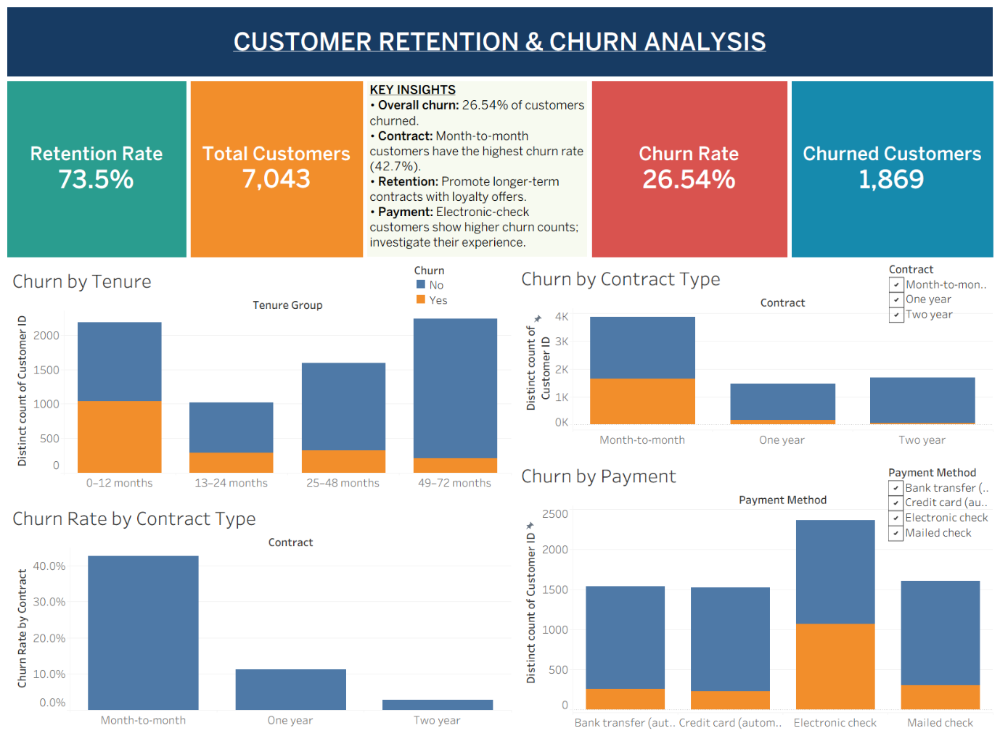The interactive Tableau dashboard contains the following visualizations:
5.1 Churn by Tenure
This visualization compares churn status across four customer-tenure groups: 0–12 months, 13–24 months, 25–48 months, and 49–72 months.
The chart helps examine how churn patterns differ between newer and longer-tenured customers. Customers in their early months of service are an important group to monitor because early disengagement can affect long-term retention.
5.2 Churn by Contract Type
This chart compares the number of churned and retained customers across month-to-month, one-year, and two-year contracts.
Month-to-month contracts have the largest customer count and the greatest number of churned customers. The chart helps identify contract groups that may benefit from targeted retention efforts.
5.3 Churn Rate by Contract Type
This visualization compares the proportion of customers who churn within each contract category.
The approximate churn rates are:
- Month-to-month: 42.7%
- One-year: 11.2%
- Two-year: 2.8%
Month-to-month customers have a substantially higher churn rate than customers with longer-term contracts. This association suggests that contract commitment is an important factor to investigate when designing retention strategies.
5.4 Churn by Payment Method
This chart compares churned and retained customers across bank transfer, credit card, electronic check, and mailed check payment methods.
Electronic-check users show a comparatively high number of churned customers. The finding should be interpreted alongside the size of each payment-method group, as a higher churn count does not necessarily mean a higher churn rate.

6. Key Findings
The analysis produced the following findings:
- Overall churn: The customer churn rate is 26.54%, indicating that a meaningful proportion of customers leave the service.
- Contract type: Month-to-month customers have the highest churn rate, at approximately 42.7%.
- Longer-term contracts: One-year and two-year contract customers show substantially lower churn rates than month-to-month customers.
- Payment method: Electronic-check users account for a comparatively high number of churned customers and warrant further investigation.
- Customer tenure: Churn patterns vary across tenure groups, highlighting the importance of examining the customer lifecycle when planning retention activities.

7. Business Recommendations
Based on the findings, the following actions are recommended:
7.1 Encourage Longer-Term Contracts
Offer suitable incentives, loyalty benefits, or discounted long-term plans to month-to-month customers who may be willing to commit for a longer period.
7.2 Improve Early Customer Engagement
Introduce onboarding support, timely follow-ups, and early satisfaction checks to identify problems before customers decide to leave.
7.3 Investigate Electronic-Check Customers
Review the billing and payment experience of electronic-check users. Examine whether payment difficulties, customer preferences, or other service factors are associated with churn.
7.4 Introduce Targeted Retention Campaigns
Use customer tenure, contract type, and other relevant characteristics to identify groups that may benefit from personalized offers or proactive support.
7.5 Monitor Churn Regularly
Track churn rate, retention rate, and customer-level trends over time using an interactive dashboard to evaluate whether retention initiatives are effective.

8. Conclusion
This project analyzed customer retention and churn using the Telco Customer Churn dataset and Tableau. The analysis identified an overall churn rate of 26.54% and a retention rate of approximately 73.46%.
Contract type emerged as a key factor associated with churn, with month-to-month customers showing the highest churn rate. Payment-method patterns and differences across tenure groups also provide useful directions for further investigation.
The interactive dashboard presents these findings in an accessible format and supports data-driven decision-making. By using the insights to improve onboarding, strengthen customer engagement, investigate payment-related concerns, and encourage longer-term relationships, businesses can develop more focused customer-retention strategies.

Project Deliverable: Interactive Tableau dashboard for customer retention and churn analysis.
Tools: Tableau and Microsoft Excel

